**Assignment – 3**

**Student Name:** Vivek Kumar  **UID:** 21BCS8129

**Branch:** BE-CSE (LEET) **Section/Group:** 809/A

**Semester:** 4th **Date of Performance:** 06/03/2022

**Subject Name:** Computer Network **Subject Code:** 20CSP-256

**1. Aim/Overview of the practical:**

How multimedia helps in application layer. Take examples to support your answer?

**Theories:**

Sliding window protocols are data link layer protocols for reliable and sequential delivery of data frames. The sliding window is also used in Transmission Control Protocol.

In this protocol, multiple frames can be sent by a sender at a time before receiving an acknowledgment from the receiver. The term sliding window refers to the imaginary boxes to hold frames. Sliding window method is also known as windowing.

## Working Principle

In these protocols, the sender has a buffer called the sending window and the receiver has buffer called the receiving window.

The size of the sending window determines the sequence number of the outbound frames. If the sequence number of the frames is an n-bit field, then the range of sequence numbers that can be assigned is 0 to 2𝑛−1. Consequently, the size of the sending window is 2𝑛−1. Thus, in order to accommodate a sending window size of 2𝑛−1, a n-bit sequence number is chosen.

The sequence numbers are numbered as modulo-n. For example, if the sending window size is 4, then the sequence numbers will be 0, 1, 2, 3, 0, 1, 2, 3, 0, 1, and so on. The number of bits in the sequence number is 2 to generate the binary sequence 00, 01, 10, 11.

The size of the receiving window is the maximum number of frames that the receiver can accept at a time. It determines the maximum number of frames that the sender can send before receiving acknowledgment.

## Example

Suppose that we have sender window and receiver window each of size 4. So, the sequence numbering of both the windows will be 0,1,2,3,0,1,2 and so on. The following diagram shows the positions of the windows after sending the frames and receiving acknowledgments.

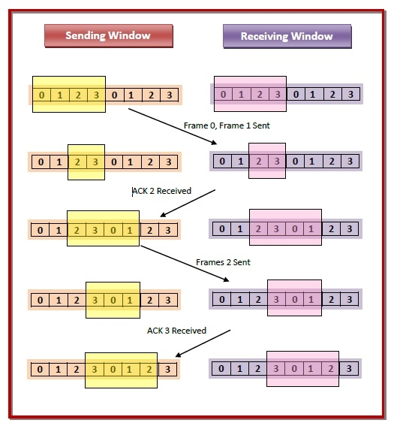

## Stop and Wait protocol

Stop and Wait protocol is a protocol for flow control mechanism. In this protocol, sender sends one frame at a time and waits for acknowledgment from the receiver. Once acknowledged, sender sends another frame to the receiver.

## Sliding Window protocol

Stop and Wait protocol is also a protocol for flow control mechanism. In this protocol, sender sends multiple frames at a time and retransmit the frames which are found to be corrupted or damaged.

| **Sr. No.** | **Key** | **Stop and Wait protocol** | **Sliding Window protocol** |
| --- | --- | --- | --- |
| 1 | Mechanism | In Stop and Wait protocol, sender sends single frame and waits for acknowledgment from the receiver. | In Sliding window protocol, sender sends multiple frames at a time and retransmits the damamged frames. |
| 2 | Efficiency | Stop and Wait protocol is less efficient. | Sliding Window protocol is more efficient than Stop and Wait protocol. |
| 3 | Window Size | Sender's window size in Stop and Wait protocol is 1. | Sender's window size in Sliding Window protocol varies from 1 to n. |
| 4 | Sorting | Sorting of frames is not needed. | Sorting of frames helps increasing the efficiency of the protocol. |
| 5 | Efficiency | Stop and Wait protocol efficiency is formulated as 1/(1+2a) where a is ratio of propagation delay vs transmission delay. | Sliding Window protocol efficiency is formulated as N/(1+2a) where N is no. of window frames and a is ratio of propagation delay vs transmission delay. |
| 6 | Duplex | Stop and Wait protocol is half duplex in nature. | Sliding Window protocol is full duplex in nature. |

**Evaluation Grid (To be created as per the SOP and Assessment guidelines by the faculty):**

|  |  |  |  |
| --- | --- | --- | --- |
| Sr. No. | Parameters | Marks Obtained | Maximum Marks |
| 1. |  |  |  |
| 2. |  |  |  |
| 3. |  |  |  |
|  |  |  |  |